HDOC day-12
Prepare the algorithm and test case table. Then write, compile, execute, and test the C program against the prepared use cases.
Write a menu-driven C program using switch-case to input a positive integer and perform one of the following operations based on the user’s choice:
- Find the sum and product of the first and last digits. E.g. Number: 12345, Sum = 6, Product = 5
- Count how many digits are lesser than, equal, and greater than a given digit `k`. E.g. Number: 12345, k=3, Count_lesser=2, Count_equal=1, Count_greater=2

Aim: To write a C program using switch-case to perform the given operations on a positive integer
Algorithm
1)Start.
2)Enter a positive integer n.
3)Find the last digit of the number.
4)Find the first digit of the number.
5)Calculate sum = first digit + last digit.
6)Calculate product = first digit × last digit.
7)Display the sum and product.
8)stop.
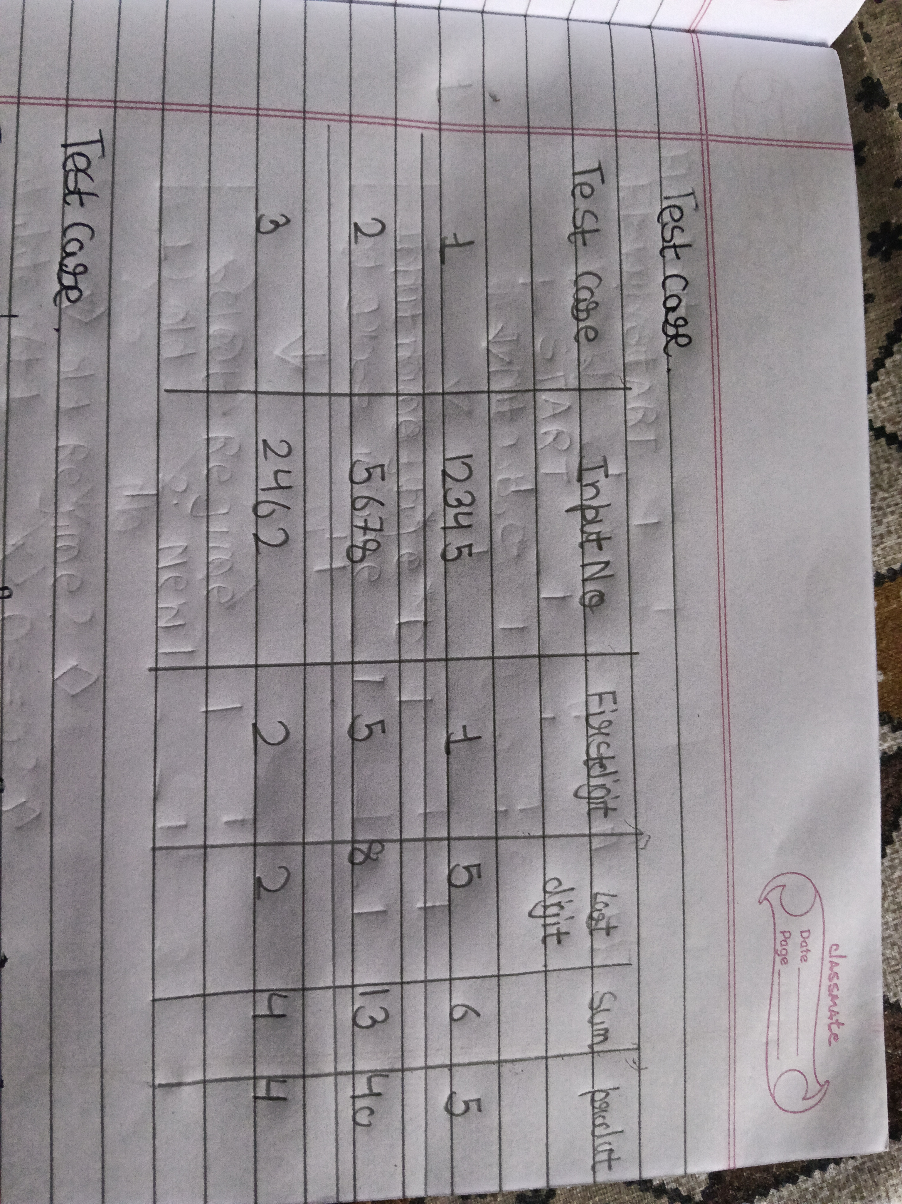

C code
#include <stdio.h>

int main()
{
int n, first, last;

printf("Enter a number: ");
scanf("%d", &n);

last = n % 10;
first = n;

while(first >= 10)
{
first = first / 10;
}

printf("Sum = %d\n", first + last);
printf("Product = %d\n", first * last);

return 0;
}

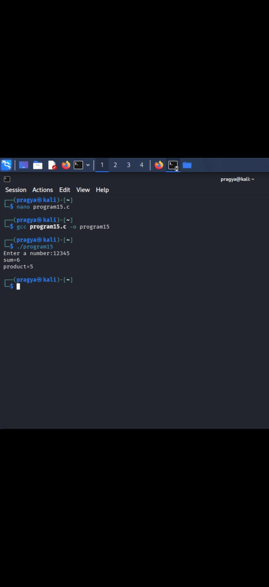
2. Count digits less than, equal to, and greater than
Algorithm
1)Start.
2)Enter a positive integer n.
3)Enter a digit k.
4)Take three counters: less = 0, equal = 0, greater = 0.
5)Check each digit of the number.
6)If digit is less than k, increase less.
7)If digit is equal to k, increase equal.
8)If digit is greater than k, increase greater.
9)Display all three counts.
10)Stop.
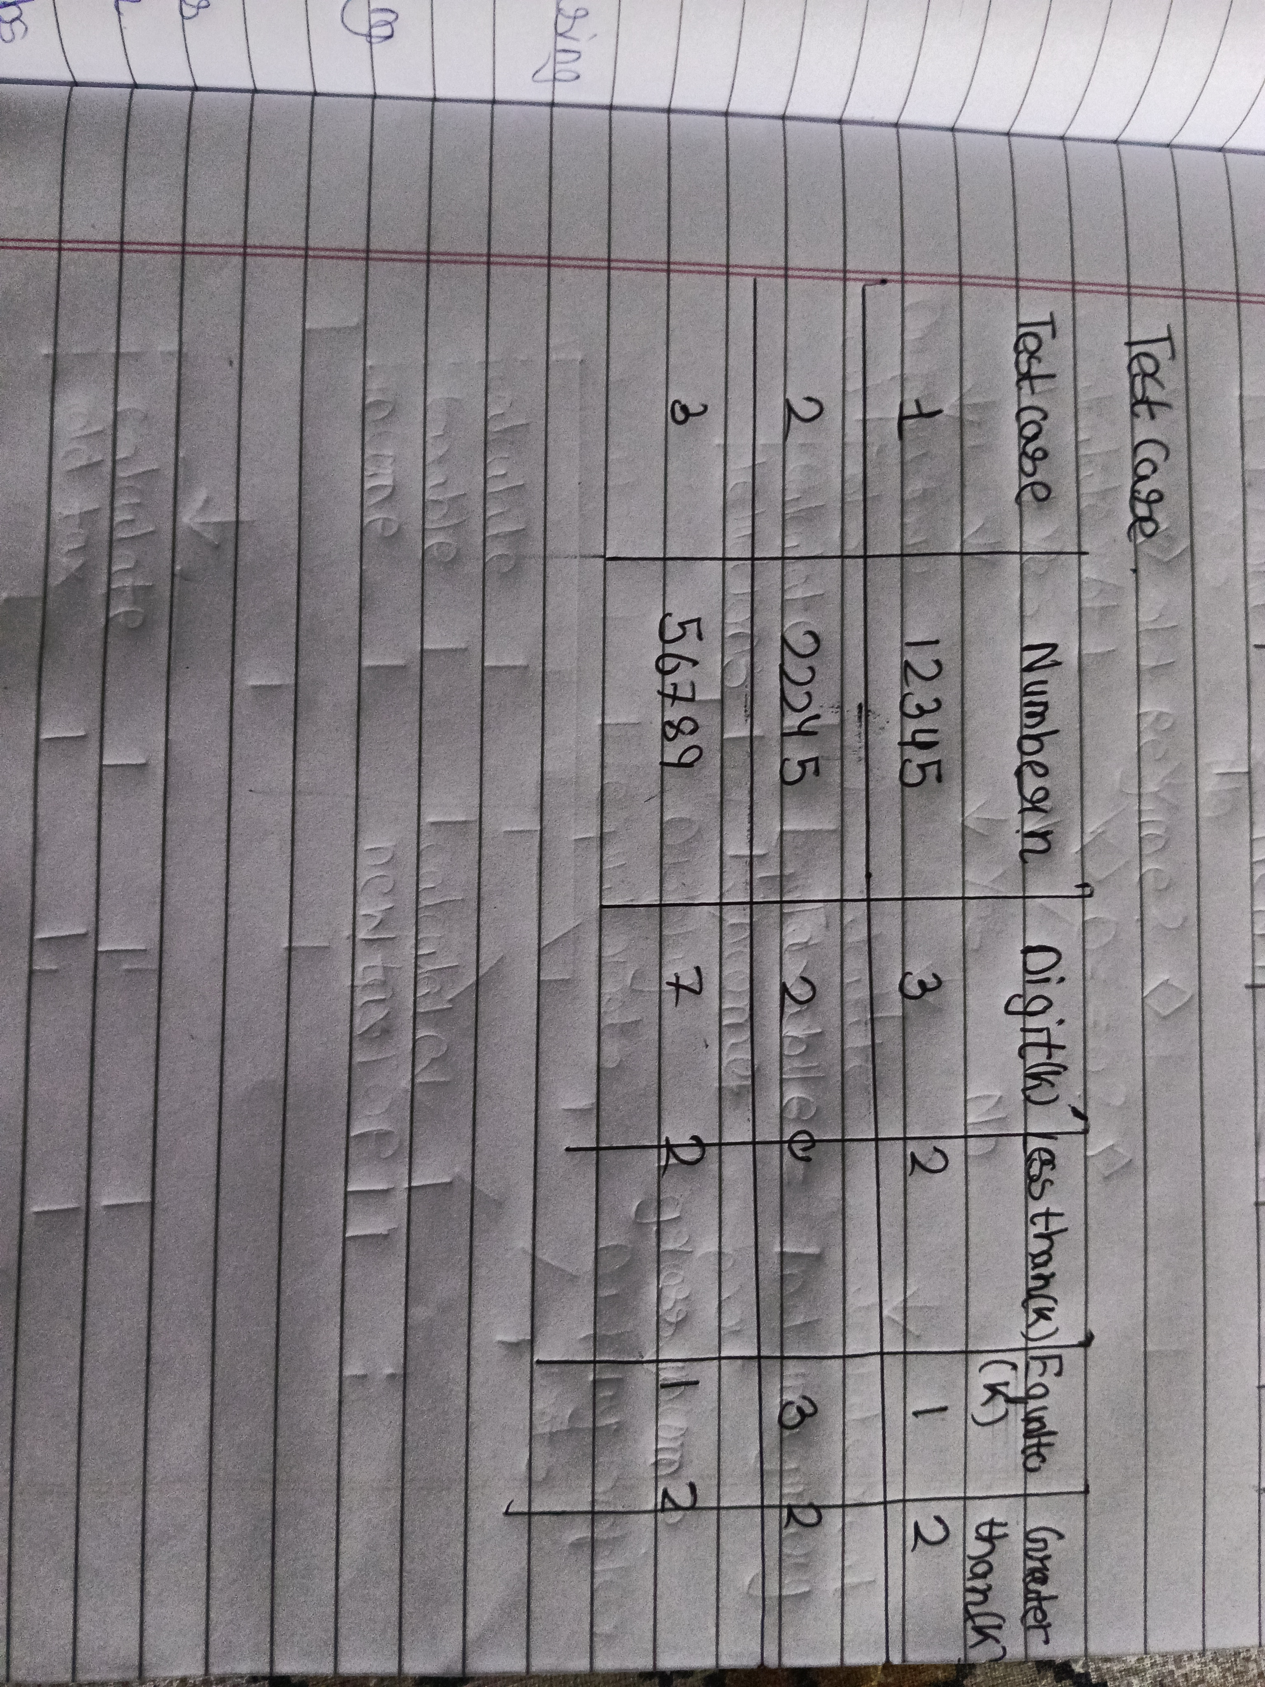
C code
#include <stdio.h>

int main()
{
int n, k, digit;
int less = 0, equal = 0, greater = 0;

printf("Enter a number: ");
scanf("%d", &n);

printf("Enter k: ");
scanf("%d", &k);

while(n > 0)
{
digit = n % 10;

if(digit < k)
less++;
else if(digit == k)
equal++;
else
greater++;

n = n / 10;
}

printf("Less = %d\n", less);
printf("Equal = %d\n", equal);
printf("Greater = %d\n", greater);

return 0;
}

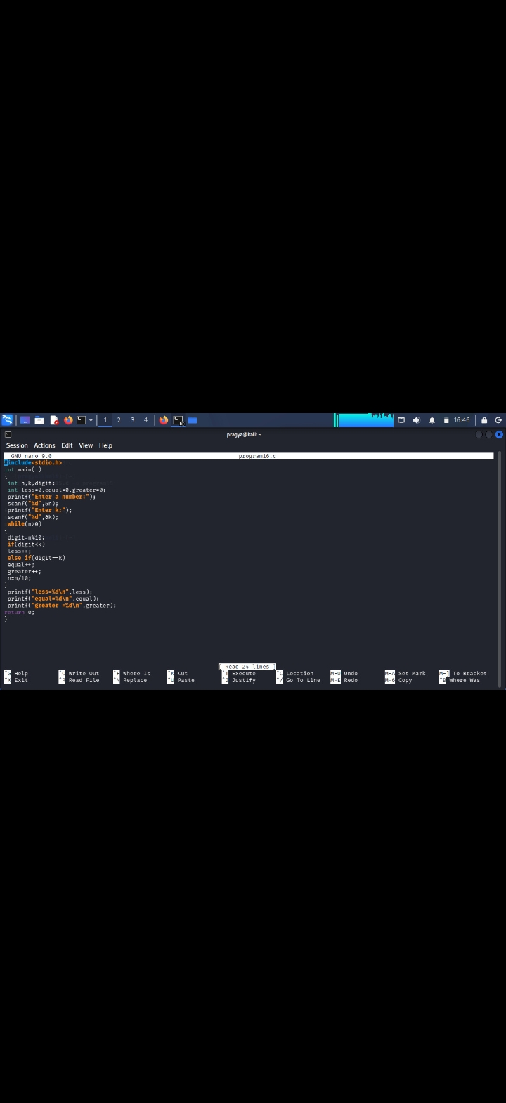

Result

